Boot Camp/End of Term Spring Trainer: Sarthak Kumar Panda Submission Deadline: 21st May, 2024 11:59pm EST (Both PART 1 & 2) Topic: Interview Questions, Designing Framework as per
Acceptance Criteria

Weekday Batch: Date – 26th Mar 2024

Submission Instructions: -

- Please submit your theoretical answers in Word or pdf document.

- Please submit your framework design in the form of GitHub link.

- Execution from command prompt – attach screenshots.

- Every theory question has to be answered.


[DOCUMENT TITLE] | PANDA, SARTHAK

Tamanna Begum(8722NJ_Tamanna Begum )
Batch – 132

1. FRAMEWORK DESIGN_Hybrid: -

Acceptance Criteria

- Use the url - http://tutorialsninja.com/demo

- Create MAVEN Project.

- Execution of all Test Cases should be in Chrome Browser

- Login, Register and Search Product needs to be validated.

- Add a valid product and complete the checkout

- TestNG should be used extensively.

- Listeners to be implemented.

- Extent Reports to be used.

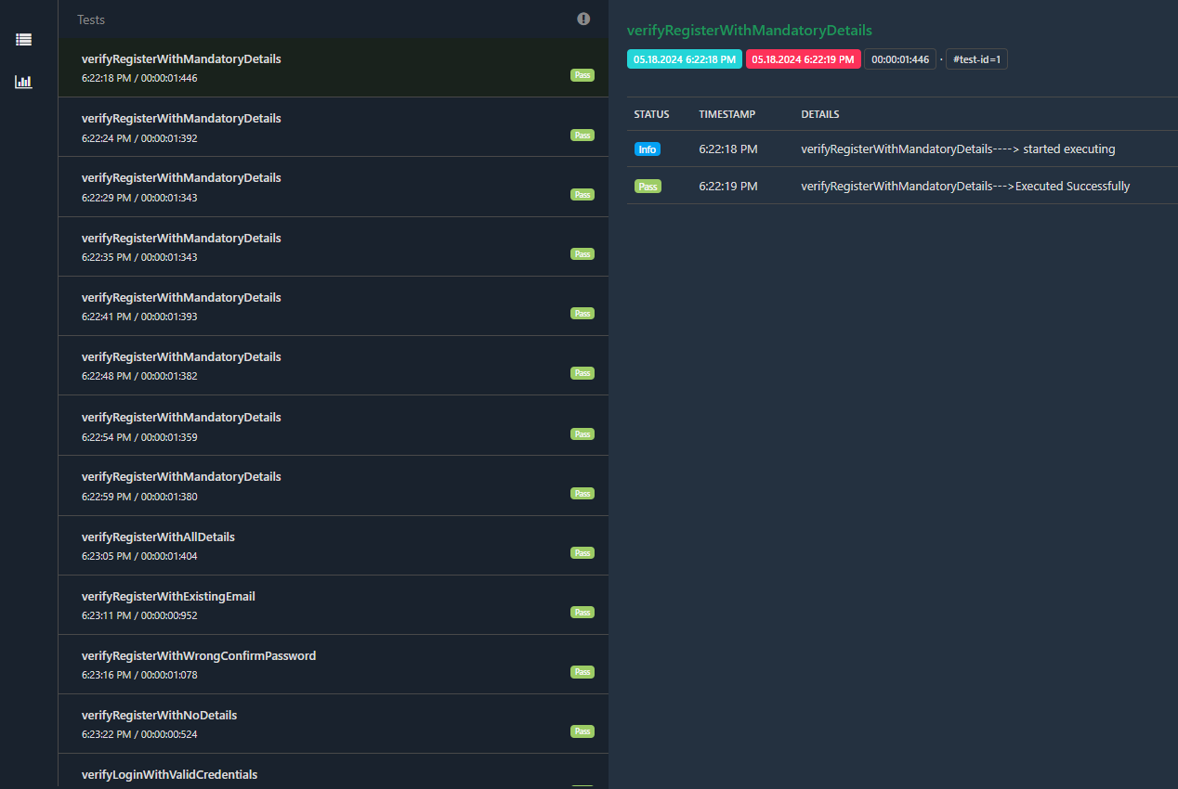

- Push the code to GitHub.

https://github.com/kazitami/BOOTCAMP2_HYBRID_FRAMEWORK_MAVEN_PROJECT

- Execute the code in cmd terminal.

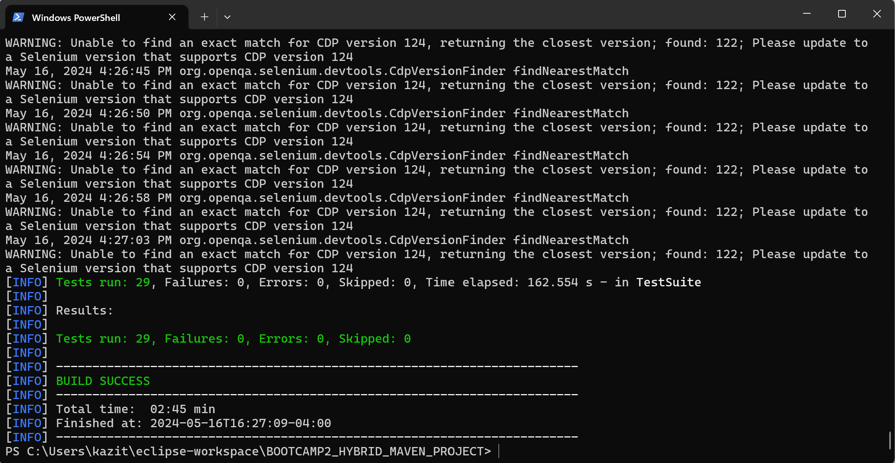

- Setup Jenkins and execute code in JENKINS.
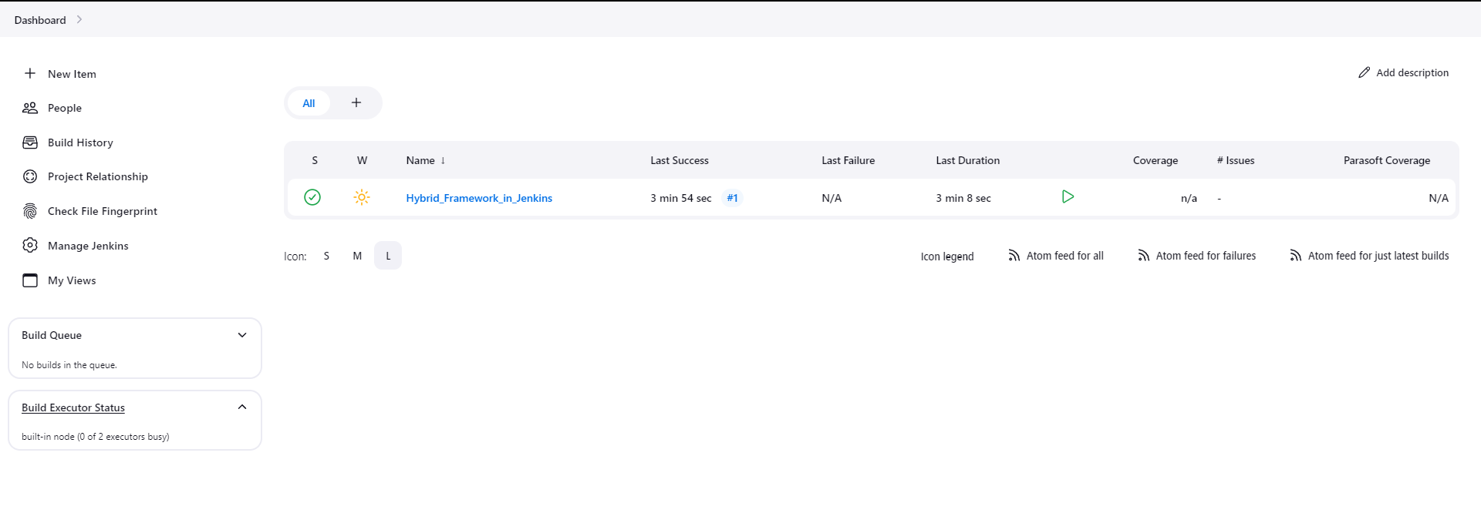

2. FRAMEWORK DESIGN_BDD_Cucumber: -
Acceptance Criteria

- Use the url - http://tutorialsninja.com/demo

- Create MAVEN Project.

- Add all maven dependencies related to Cucumber

- Prepare necessary feature files related to Login, Register, SearchProduct, AddToCart, Logout scenarios.

- Execution of all Test Scenarios should be in Chrome Browser

- Junit/TestNG either can be used in Runner files.

- Listeners to be implemented.

- Extent Reports to be used.

- Push the code to GitHub.

https://github.com/kazitami/BOOTCAMP2_BDD_CUCUMBER_FRAMEWORK

- Execute the code in cmd terminal.

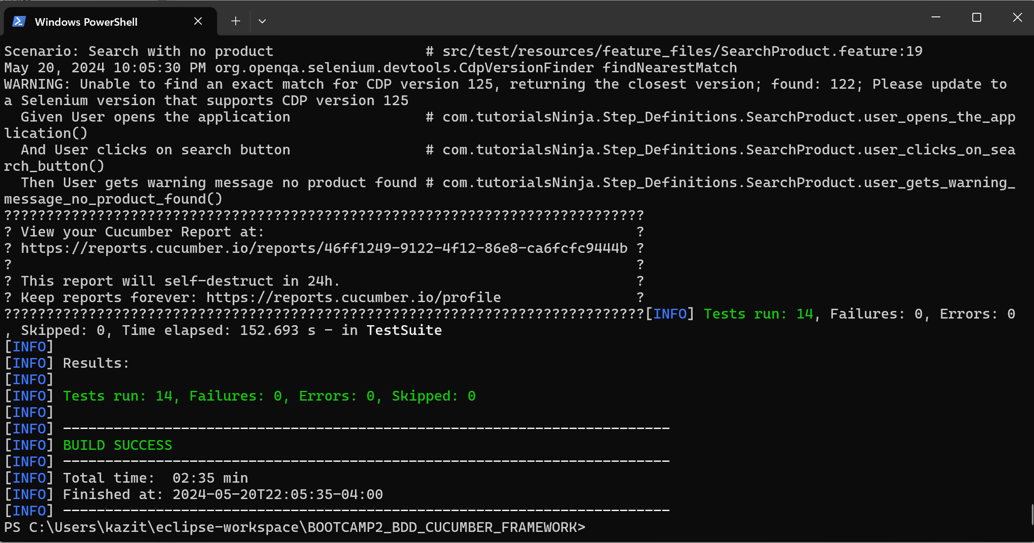

- Setup Jenkins and execute code in JENKINS.

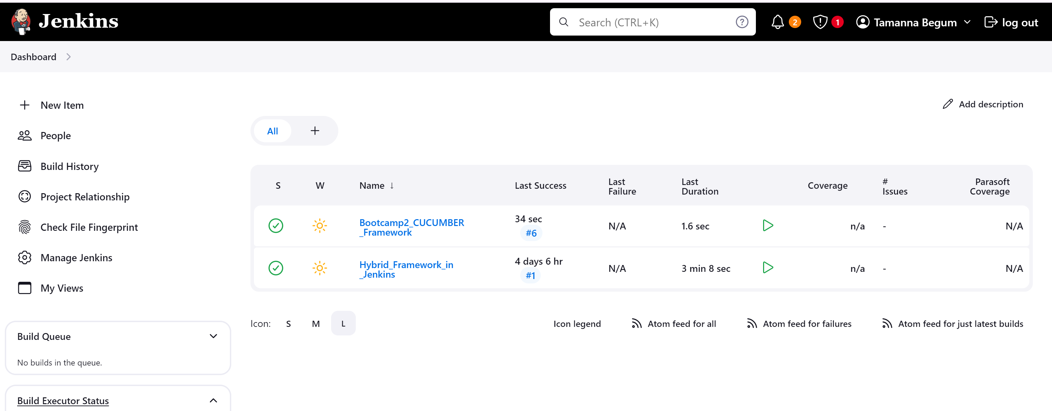

THEORETICAL QUESTIONS: -
----------------------------------------------------------------------------------------------------------------------------
3. What is Selenium ? What are the different components and versions of Selenium?
Ans:
Selenium WebDriver is a web framework that permits you to execute cross-browser tests. This tool is used for automating web-based application testing to verify that it performs expectedly.

Different Components:
Selenium IDE, Selenium RC, Selenium WebDriver and Selenium GRID.

Versions: Selenium 1, Selenium 2, Selenium 3 and Selenium 4.
----------------------------------------------------------------------------------------------------------------------------

4. What are Locators, different types of locators and their priorities in Selenium?
Ans:
Locators:
A locator is a way to identify elements on a page.

Types of locators in selenium: ID,Name,Class,Xpath,CssSelectors,LinkText,PartialLinkText and TagName.

Locators priorities in selenium goes by :
First ID locator > Then Name > Then className> Then linkText> Then cssSelector> the Xpath expression.

----------------------------------------------------------------------------------------------------------------------------

5. What are the different types of drivers in Selenium WebDriver?
Ans: ChromeDriver, FirefoxDriver, InternetExplorerDriver, SafariDriver, OperaDriver, EdgeDriver,RemoteWebDriver

----------------------------------------------------------------------------------------------------------------------------
6. How do I launch the browser using WebDriver?

Ans:
WebDriver driver = new ChromeDriver();
driver.get(“Url”);

----------------------------------------------------------------------------------------------------------------------------

7. What are the different types of navigation commands in WebDriver?

Ans: to(), back(), forward(),refresh()
For example:
driver.navigate().to(“URL”);
driver.navigate().back();
driver.navigate().forward();
driver.navigate().refresh();

----------------------------------------------------------------------------------------------------------------------------
8. How can you find whether an element is displayed on the screen using Selenium?

Ans: Using isDisplayed() method.
For example:
driver.findElement(By.ld(“elementid”)).isDisplayed();
----------------------------------------------------------------------------------------------------------------------------

9. How can we get a text on a web element using Selenium WebDriver?

Ans: By using getText() method, we can get text from web element.
For example:
driver.findElement(By.xpath(“element”)).getText();

----------------------------------------------------------------------------------------------------------------------------
10. How to type into a text box using Selenium?

Ans:
To type into a text box using Selenium, you can use the sendkeys() method:
1. Identify the web element you want to interact with, such as a text box or an input
field.
2. Use the WebDriver's findElement() method to locate the element.
3. Call the sendKeys() method on that element, passing in the text you want to
enter.
For example: driver.findElement(By.id(“elementid”)).sendKeys(“Hello”);

----------------------------------------------------------------------------------------------------------------------------

11. How to handle a drop-down field and select a value from it using Selenium?

Ans:

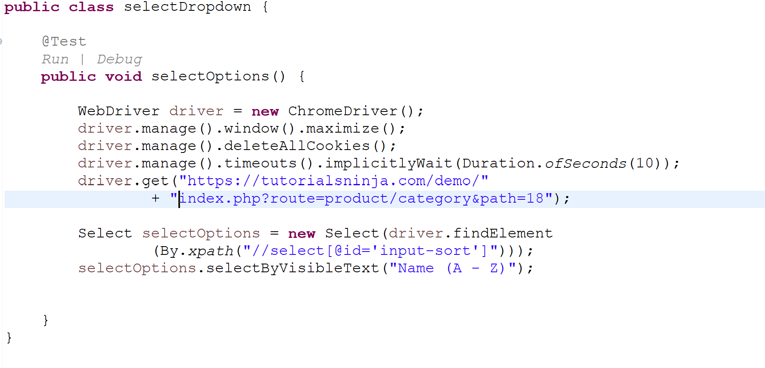

----------------------------------------------------------------------------------------------------------------------------

12. What are the different types of waits available in WebDriver?

Ans: implicit wait, explicit wait and fluent wait

----------------------------------------------------------------------------------------------------------------------------
13. What is the latest Selenium tool?

Ans: Selenium 4 is the latest version of the Selenium automation testing framework.
----------------------------------------------------------------------------------------------------------------------------

[DOCUMENT TITLE] | PANDA, SARTHAK

14. What do we mean by Selenium 1, Selenium 2, Selenium 3 and Selenium 4?

Ans: Selenium 1, Selenium 2, Selenium 3, and Selenium 4 are the four versions of Selenium.

----------------------------------------------------------------------------------------------------------------------------
15. When should I use Selenium Grid?

Ans:
Selenium Grid is a component of Selenium that can be used to run tests in parallel against different browsers, operating systems, and browser versions. This allows for parallel testing, which can reduce the time it takes to execute a test suite. For example, if 10 tests are each taking one minute to execute, Selenium Grid can distribute the tests across five machines, allowing five tests to be executed at the same time, saving two minutes.
----------------------------------------------------------------------------------------------------------------------------

16. What is the difference between / and // in Xpath?
Ans:
In XPath, the difference between / and // is:
Absolute XPath: An XPath expression that starts with /
Relative XPath: An XPath expression that starts with //

----------------------------------------------------------------------------------------------------------------------------
17. What is an Xpath?
Ans:
XPath stands for XML Path Language. XPath is a major element in the XSLT standard. XPath is a query language and can be used to navigate through elements and attributes in an XML document.

----------------------------------------------------------------------------------------------------------------------------

18. What is the difference between driver.close() and driver.quit() commands?

Ans:
driver.close() method → closes current browser.
Driver.quit() method → closes all browser windows and tabs associated with the WebDriver instance.Terminates the WebDriver session.

----------------------------------------------------------------------------------------------------------------------------
19. Is WebDriver a class or interface?
Ans: WebDriver is an Interface.

----------------------------------------------------------------------------------------------------------------------------
20. What is the super interface of WebDriver?
Ans:
SearchContext is the super interface of WebDriver interface in Selenium WebDriver API.

----------------------------------------------------------------------------------------------------------------------------
21. How to find more than one web element in to a list?

Ans: Using findElements() method in WebDriver.
Examples:
List<WebElement> element = driver.findElements(By.id(“elementId“));

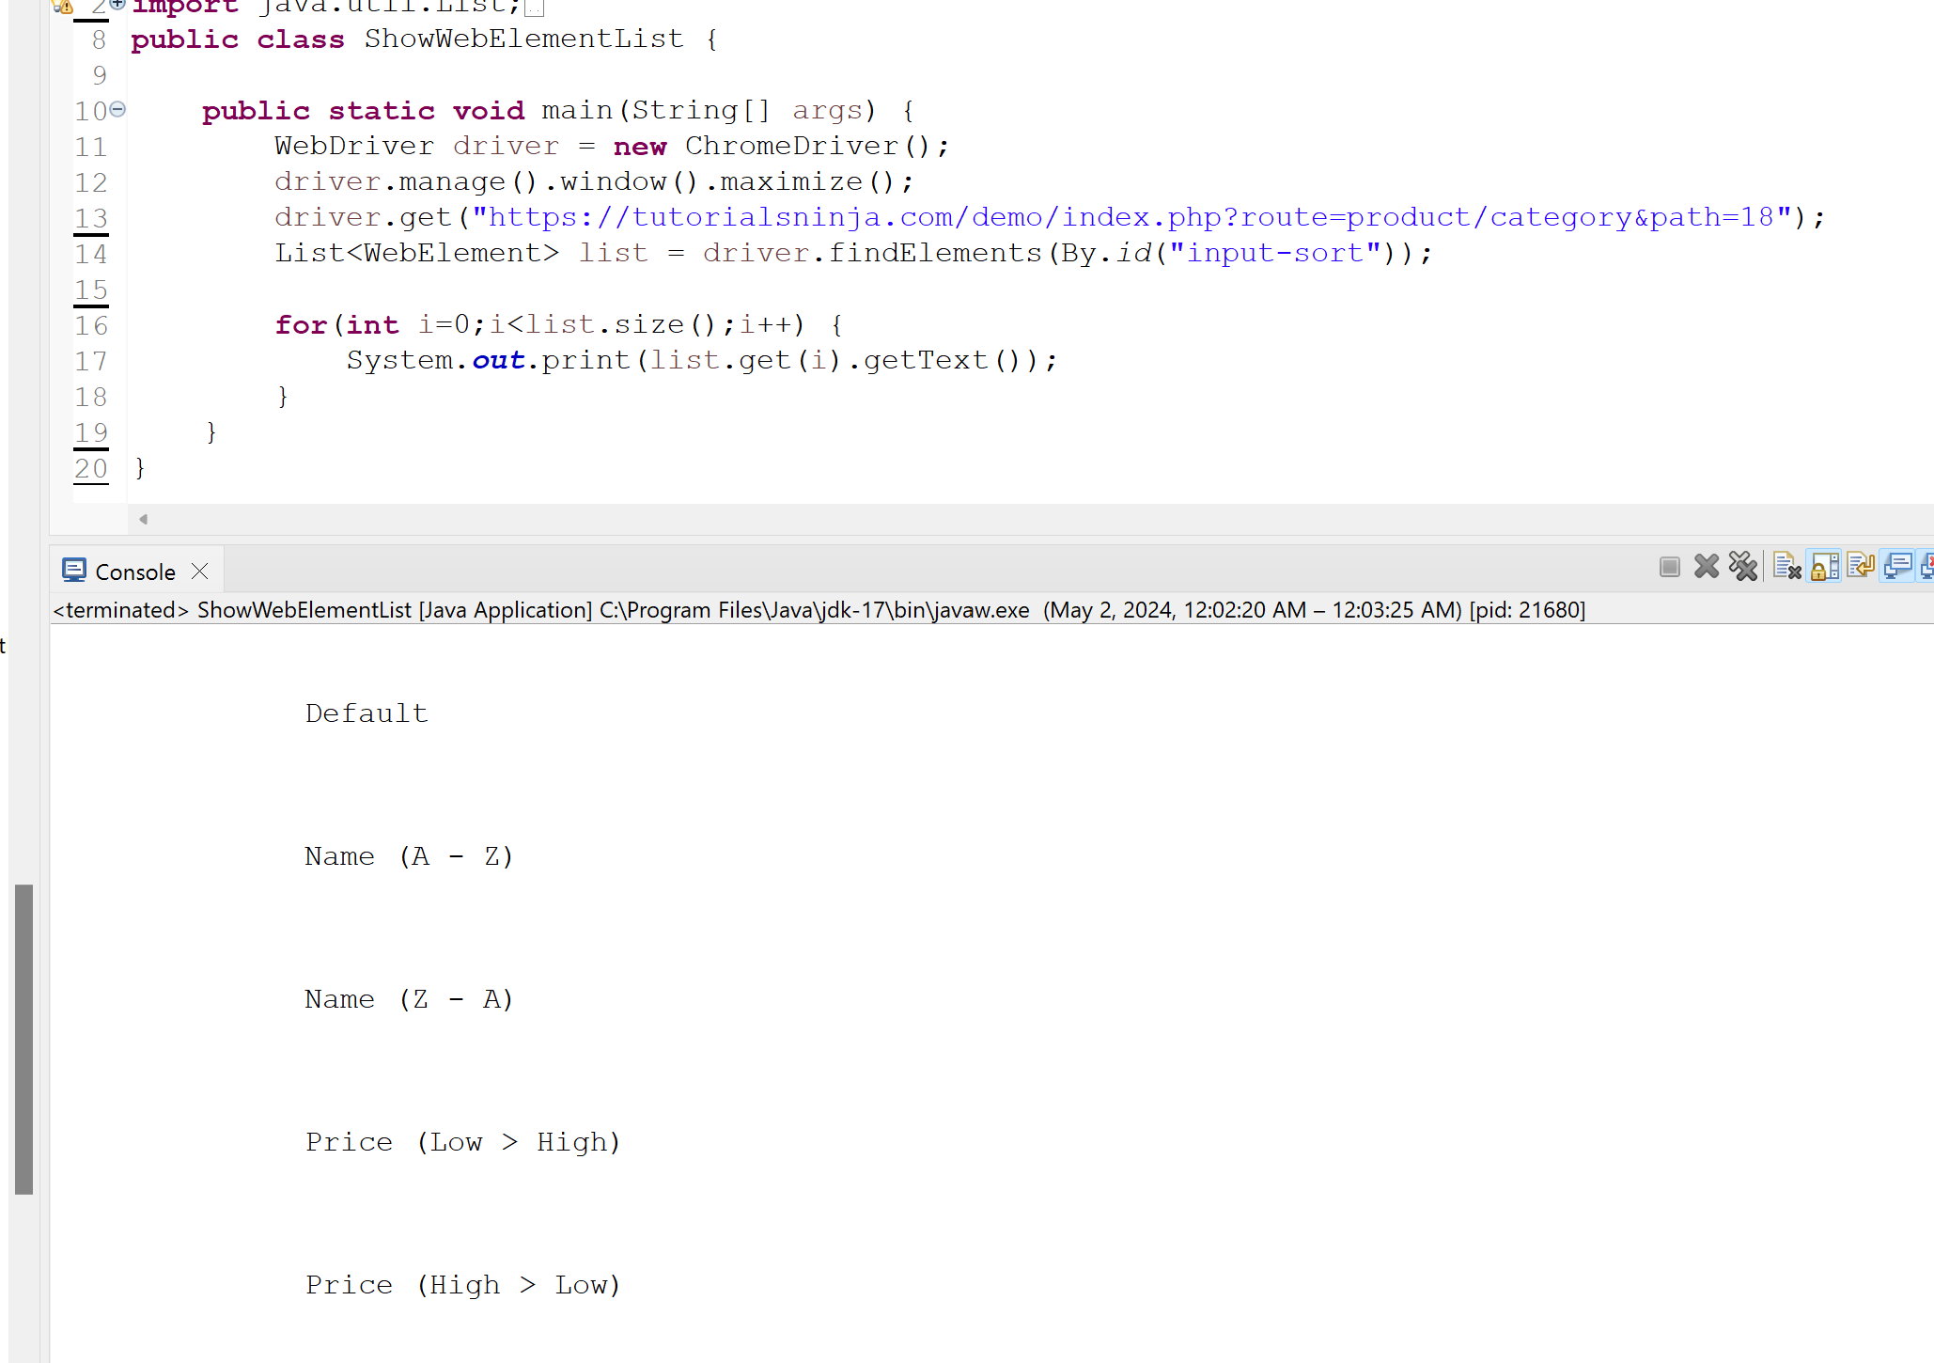

----------------------------------------------------------------------------------------------------------------------------

22. Is FirefoxDriver a class or interface?

Ans: FirefoxDriver is a class that implements the WebDriver interface in Selenium WebDriver.

----------------------------------------------------------------------------------------------------------------------------

23. Explain the line of code WebDriver driver = new FirefoxDriver();?

Ans: WebDriver driver = new FirefoxDriver(); creates a new Instance of the Firefox driver and assigns it to the reference variable of the WebDriver interface.

----------------------------------------------------------------------------------------------------------------------------

[DOCUMENT TITLE] | PANDA, SARTHAK

24.How to handle frames in WebDriver
Ans: First Identify frames by index, Name or ID, or WebElement for example:

by index:-
driver.switchTo().frame(index);

by Name or ID:-
driver.switchTo().frame("frameNameOrId");

by WebElement:-
driver.switchTo().frame(frameElement);

After switching the focus, you can interact with the elements within the frame using the same WebDriver methods you would use for regular page elements.

Switch Back (based on your requirement):

driver.switchTo().defaultContent() ;

----------------------------------------------------------------------------------------------------------------------------
25. How to click on a hyper-link using Selenium WebDriver?
Ans: Using the click() method.
driver.findElement(By.linkText("Mylink")).click();

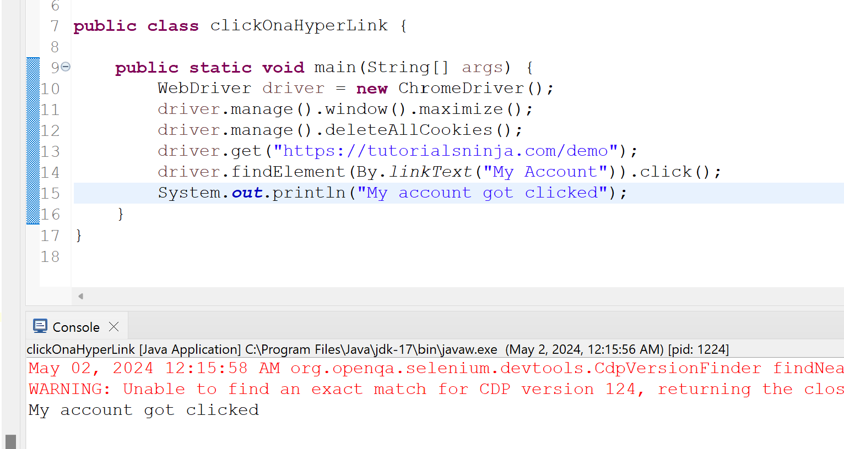

----------------------------------------------------------------------------------------------------------------------------

26. What are the programming languages supported by Selenium WebDriver?
Ans: Java, Python, c#, Ruby, JavaScript, PHP.

----------------------------------------------------------------------------------------------------------------------------

27. What are the operating systems supported by Selenium WebDriver?
Ans: Windows, macOS, Linux
----------------------------------------------------------------------------------------------------------------------------

28. What are the browsers supported by Selenium WebDriver?
Ans: Google Chrome, Mozilla Firefox, Microsoft Edge, Apple Safari, Opera.

----------------------------------------------------------------------------------------------------------------------------

29. What is the difference between Implicit Wait and Explicit Wait?
Ans:

Implicit Wait | Explicit Wait
Scope - Global | Scope – Specific element or condition
Implementation – implicitlyWait method | Implementation – WebDriverWait class
Waiting condition – Element to be present | Waiting condition- User-defined condition
Timeout behavior – Throws NoSuchElementException | Timeout behavior – Throws TimeoutException
Use Cases - General delays, occasional slow loads | Use Cases - Dynamic elements, specific states

----------------------------------------------------------------------------------------------------------------------------

30. How to read and verify the text on the tool tip using Selenium WebDriver?

Ans:

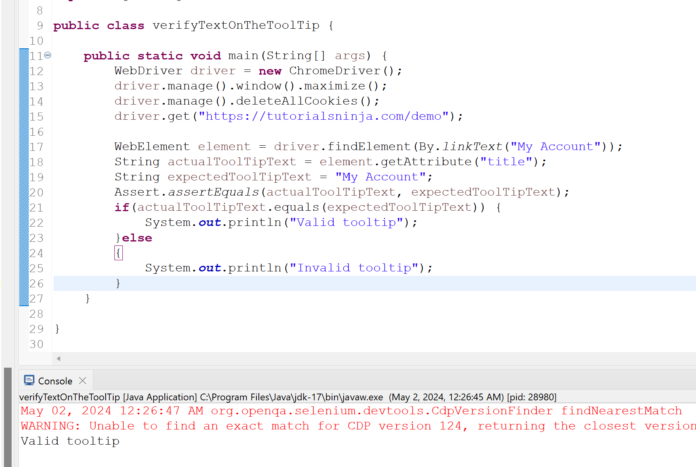

----------------------------------------------------------------------------------------------------------------------------

31. Can Selenium Automate Desktop Applications?
Ans:No, Selenium WebDriver itself cannot automate desktop applications. It's specifically designed for automating web applications that run within a web browser.

----------------------------------------------------------------------------------------------------------------------------
32. What is the main component of Selenium?
Ans: Selenium WebDriver is considered the main component of the Selenium suite. While Selenium is a collection of tools, WebDriver is the most widely used and core functionality for interacting with web browsers through code.

----------------------------------------------------------------------------------------------------------------------------

[DOCUMENT TITLE] | PANDA, SARTHAK

33. What is an XPath, difference between Absolute and Relative XPath with examples?
Ans:
XPath stands for XML Path Language. It's a query language specifically designed for navigating and selecting elements within an XML document or an HTML document treated as an XML tree.

The main difference between Absolute and Relative XPath lies in how they specify the path to an element within an HTML document

Absolute XPath | Relative XPath
Absolute XPath starts from the root element (/html) and traverses the entire hierarchy down to the target element, specifying each step along the way. | Relative XPath starts from a context node (usually a known element closer to the target element) and navigates through its relatives (siblings, parent, children) to reach the target element.
Example: /html/body/div[1]/div/div[2]/h2 | Example: //h2[text()='Products']
Absolute XPath reliable if the document structure remains consistent. | Relative XPath More flexible and adaptable to changes in the HTML structure as long as the context node remains the same.

----------------------------------------------------------------------------------------------------------------------------

34. What is the disadvantage of Absolute XPath & why is Relative XPath recommended?

Ans:
Disadvantages of Absolute XPath:
- Brittle: If any element along the absolute path (from the root element down) changes , the entire XPath expression breaks and needs to be updated.
- Less maintainable: Long absolute XPaths can be difficult to read and understand, especially for someone unfamiliar with the HTML structure.
- Less reusable: Absolute XPaths are often specific to a single element on a particular webpage. They cannot be easily reused for other elements or webpages with different structures.

Advantages of Relative XPath:
- Adaptable: Relative XPaths start from a closer context node (usually an element with a more stable identifier) and navigate through its relatives.
- More maintainable: Shorter and more focused expressions are easier to read, understand, and modify if needed.
- More reusable: Relative XPaths can often be used to target similar elements across different webpages with similar structures, improving code reusability.

----------------------------------------------------------------------------------------------------------------------------
35. What is an Absolute XPath? Write its syntax?
Ans: An Absolute XPath, in the context of Selenium WebDriver and web automation, defines a complete path from the root element (usually the <html> tag) to the target element you want to select. It essentially creates a specific address for the element within the HTML document structure.

/html/body/div[1]/section[2]/article/h3

----------------------------------------------------------------------------------------------------------------------------
36. What is a Relative XPath? Write its syntax?
Ans: In the context of Selenium WebDriver and web automation, a Relative XPath is an XPath expression that locates elements based on their relative position within the HTML document, rather than using the absolute path from the root element.

//tagName[@attribute=’value’]
//div[@class='error']

----------------------------------------------------------------------------------------------------------------------------
37. How to execute JavaScript in Selenium?
Ans:

Import the Packages:
import org.openqa.selenium.JavascriptExecutor;

Create a Reference:
WebDriver driver = new ChromeDriver();
JavascriptExecutor js = (JavascriptExecutor) driver;

Use the executeScript Method:
The executeScript method executes the provided JavaScript code within the current browser context. It takes two arguments:
for example:-

WebElement buttonElement = driver.findElement(By.id("submitButton")); js.executeScript("arguments[0].click();", buttonElement);
----------------------------------------------------------------------------------------------------------------------------

38. What is the concept that makes XPath Expressions powerful ?

Ans: The key concept that makes XPath Expressions powerful for navigating and selecting elements within XML documents is the use of axes. Axes provide a way to define the search context for XPath expressions, allowing you to traverse the hierarchical structure of an XML document in various directions.
----------------------------------------------------------------------------------------------------------------------------

39. Why CSS Selectors have higher priority over XPath Expressions?

Ans: CSS Selectors are generally preferred over XPath expressions for locating elements in web automation with Selenium WebDriver for several reasons:

Performance - | Generally faster
Maintainability - | More readable and easier to understand
Browser Compatibility | Designed for selecting elements within HTML

----------------------------------------------------------------------------------------------------------------------------

40. Names of add-ons which can auto generate the XPath Expressions and CSS Selectors?

Ans: ChroPath, SelectorsHub,Xpath Finder, SelectorsGadget

----------------------------------------------------------------------------------------------------------------------------

41. Java program for printing the even numbers between 1 and 100 using for loop?
Ans:

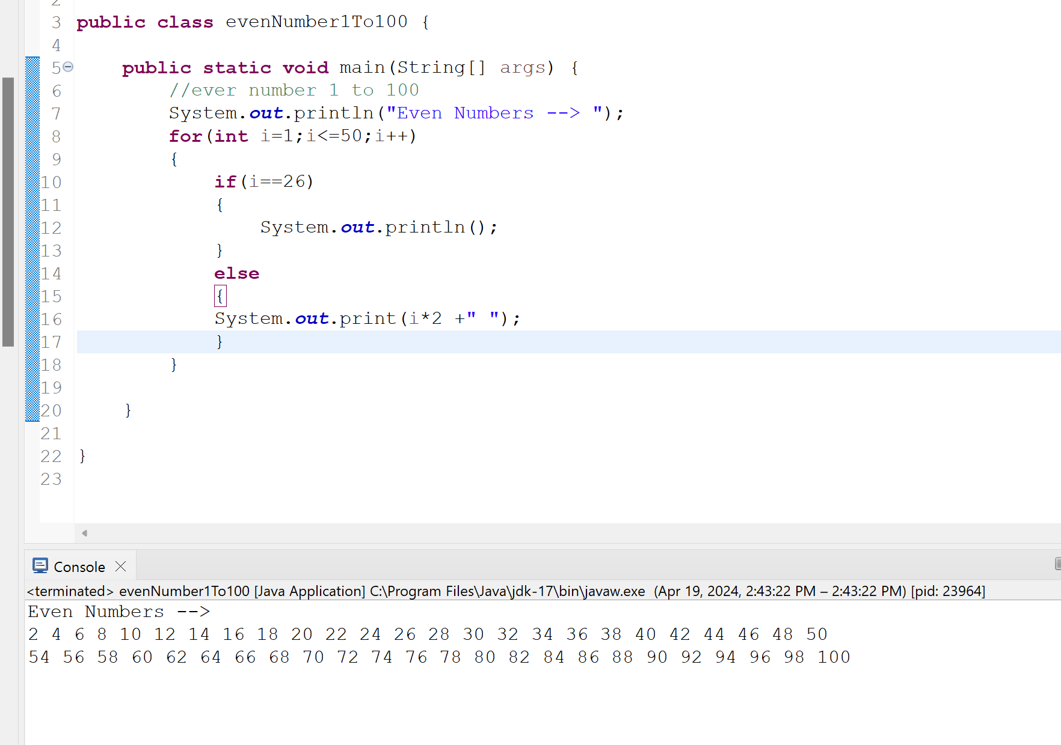

----------------------------------------------------------------------------------------------------------------------------

[DOCUMENT TITLE] | PANDA, SARTHAK

42. Write a Java program to find the sum of first 100 numbers using for loop?
Ans:
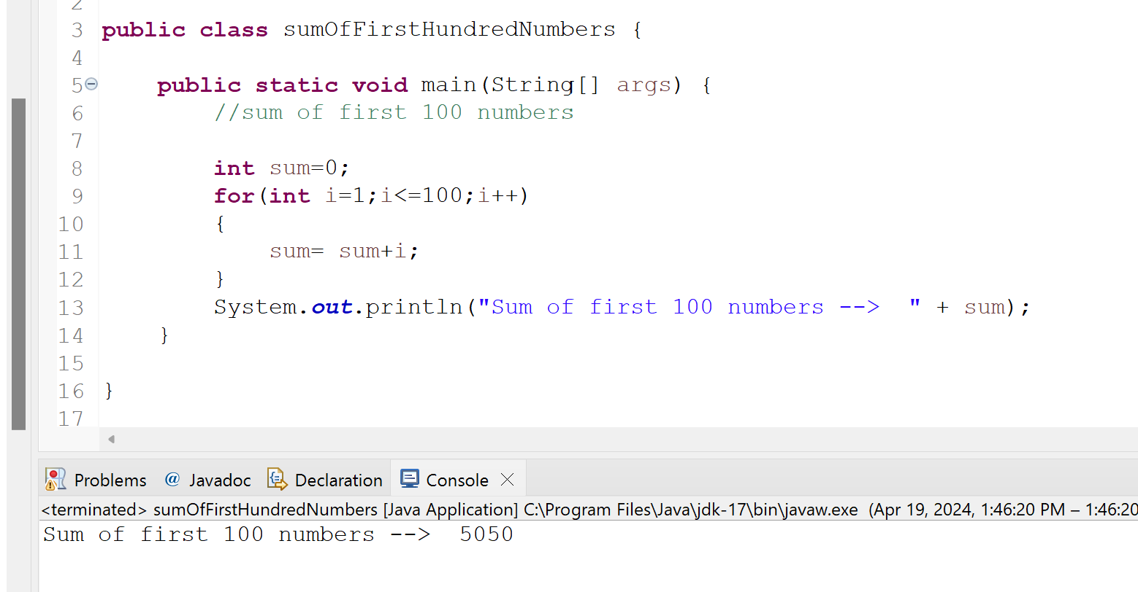

----------------------------------------------------------------------------------------------------------------------------

43. Prints numbers from 1 to 100. Print number and Divisible by 5 text if divisible?
Ans:
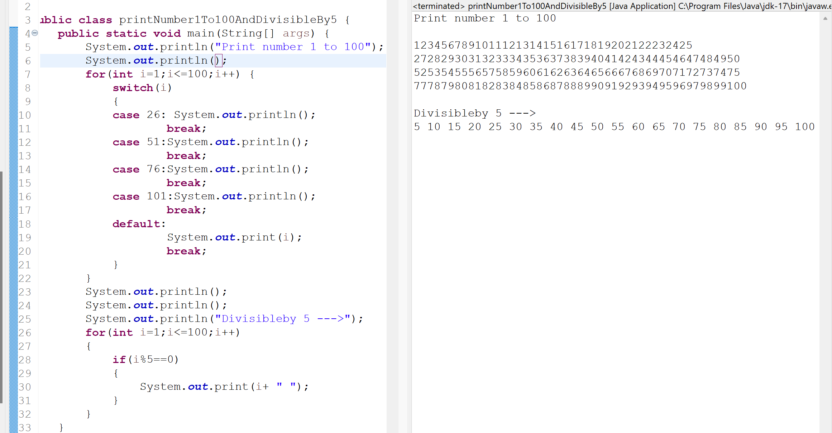

----------------------------------------------------------------------------------------------------------------------------
44. Does Java supports multiple inheritance? Give reasons?
Ans: No, Java does not support traditional multiple inheritance for classes. This means a class can inherit directly from only one parent class.

Diamond Problem: This is the primary reason for not allowing multiple inheritance. It arises when a class inherits from two parent classes that both inherit from a common ancestor class. If both parent classes have a method with the same name, there's ambiguity about which method to call from the child class. This can lead to confusion and errors.

Imagine this scenario:
Animal
/ \
Dog Cat
\ /
Pet
Pet inherits from both Dog and Cat.
- If both Dog and Cat have a method makeSound(), it's unclear which method should be called when you call makeSound() on a Pet object.

----------------------------------------------------------------------------------------------------------------------------

45. What is the parent or base class of all the classes in Java?

Ans: The parent or base class of all the classes in Java is Object Class.

----------------------------------------------------------------------------------------------------------------------------

46. What is the difference between instance variable and local variable?
Ans:

- Local vairable is declared inside a method are local variable. An instance variable is declared inside a class but outside of any method or block.

- A Local variable must be initialize before they can be used.Class variable is not compulsory to initialize instance variable before use.

- Instance variable can be accessed throughout the class , local variable has limited access only inside the method.

----------------------------------------------------------------------------------------------------------------------------

47. Is Java a pure 100% Object Oriented Programming language?

Ans: No, Java is not 100% Object Oriented Programming because of primitive data type.

----------------------------------------------------------------------------------------------------------------------------

48. What is the difference in between Primitive & Non-Primitive Data types in Java?

Ans: In Java, data types are broadly categorized into two main types: Primitive and Non-Primitive.

Primitive Data Types | Non-Primitive Data Types
Basic Building Blocks Types | Objects Types
Predefined by Java | User-defined or built-in
Fixed size | Variable size
Stored directly | Stored as redefines
No methods | Can have methods
Byte,short,Int,long,double,float,char,boolean | String, Array, class

----------------------------------------------------------------------------------------------------------------------------
49. Why Strings are immutable in Java?
Ans: Strings are immutable in Java for several reasons that contribute to better program security, performance, and maintainability. Here are the key advantages:
- Security
  - Thread Safety
  - Immutable Strings prevent accidental modifications
- Performance
  - String Pooling
- Maintainability
  - Predictable Behavior
  - Reduced Errors

----------------------------------------------------------------------------------------------------------------------------

50. What is the difference between String and StringBuffer?
Ans:

String | StringBuilder
immutable | Mutable
Thread-safe | Not thread-safe
Constant data, error messages, configurations | Building String dynamically, string concatanation

----------------------------------------------------------------------------------------------------------------------------

[DOCUMENT TITLE] | PANDA, SARTHAK

51. Accessing all elements inside int[][] a = {{5,2,9},{4,6,8}}; using for loop?
Ans:

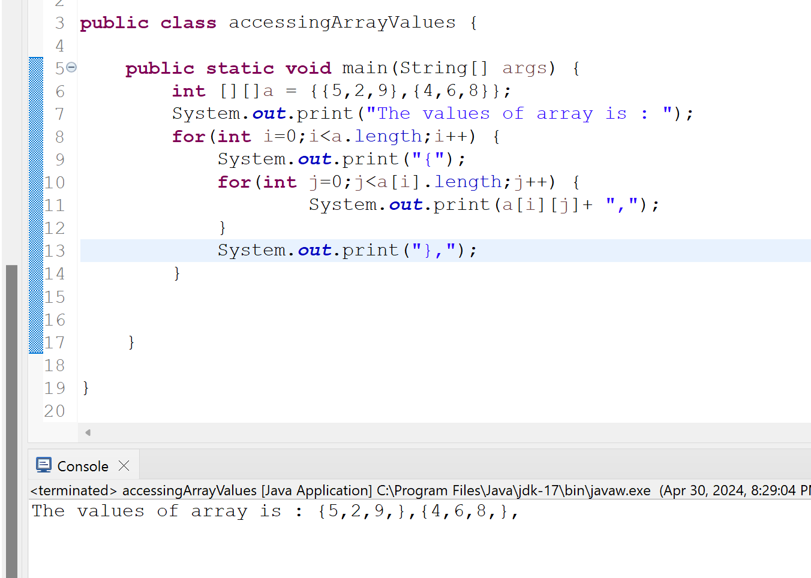

----------------------------------------------------------------------------------------------------------------------------

52. Assign different values say integer, character, string etc into a single array?
Ans:

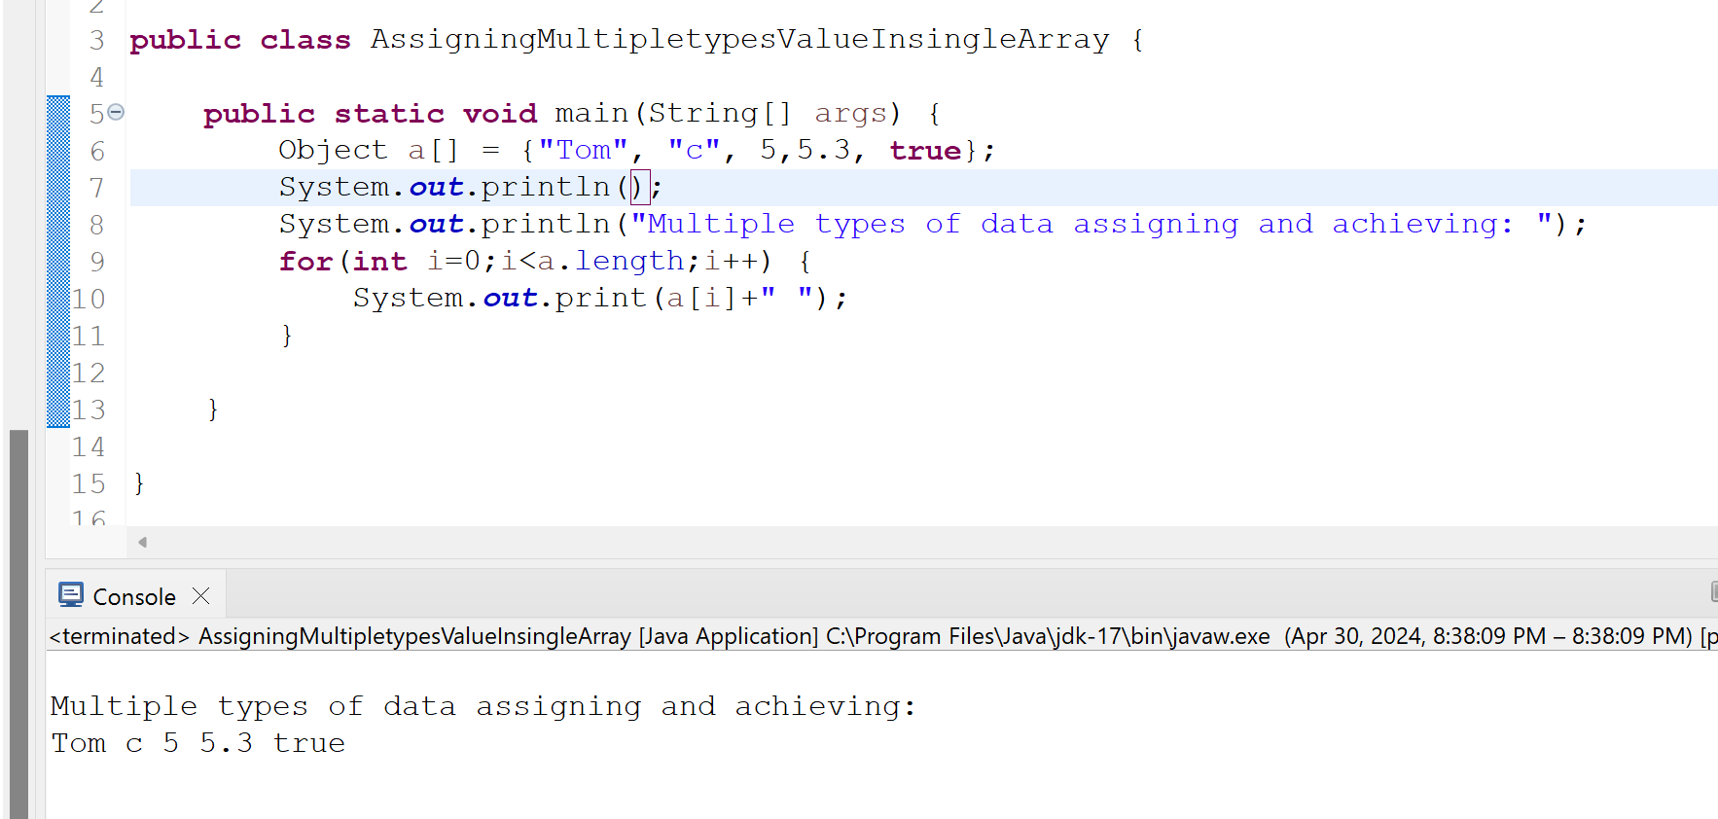

----------------------------------------------------------------------------------------------------------------------------
53. What is the disadvantage of array?
Ans:
Here are some of the key disadvantages of arrays:
- Fixed size - Once an array is created, its size cannot be changed.
- Memory Waste: Allocates memory for unused elements

----------------------------------------------------------------------------------------------------------------------------

54. What is the difference between equals() and == operator?
Ans:
- First equals() is a method and == is an operator
- The Java string equals() method, compares two strings and returns boolean result.
- The == operator for reference comparison and equals method for content comparison.

----------------------------------------------------------------------------------------------------------------------------
55. What is the purpose of using Wrapper classes in Java?
Ans:
Bridging the gap between primitives and objects:
Primitive data types like int, float, char, and boolean are fundamental data types in Java, but they are not objects. Wrapper classes (Integer, Float, Character, Boolean) provide a way to represent primitive data types as objects. This allows them to benefit from object-oriented features.

Enabling Collections and Generics:
Java collections like ArrayList and HashMap can only store objects. Wrapper classes allow primitive data types to be wrapped as objects so they can be stored in collections. Generics (introduced in Java 5) further leverage wrapper classes to create type-safe collections that can hold specific wrapper class types.

Providing utility methods:
Wrapper classes offer various methods that can be helpful when working with primitive data types. These methods include conversion methods (e.g., parseInt(), valueOf()), comparison methods (e.g., equals(), compareTo()), and methods for minimum/maximum values (MIN_VALUE, MAX_VALUE).

----------------------------------------------------------------------------------------------------------------------------
56. How to capture screen-shot in Selenium WebDriver?
Ans:

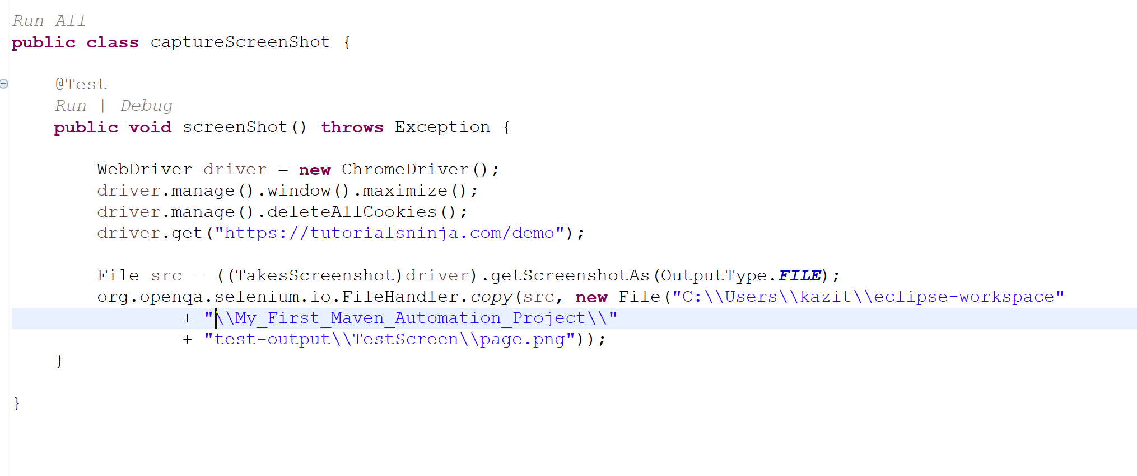

----------------------------------------------------------------------------------------------------------------------------

57. What is Automation Testing?

Ans: In software development, automation testing is the practice of using specialized software tools to execute tests on applications. It automates tasks.

- Increased Efficiency: Repetitive tests can be automated, saving testers time and effort.
- Improved Accuracy: Automation reduces human errors that can occur during manual testing.
- Faster Feedback: Tests can be run more frequently, providing quicker insights into potential issues.
- Increased Test Coverage: A larger volume of tests can be executed automatically, covering more areas of the application.
- Regression Testing: Automated tests can be easily re-run to ensure functionality hasn't regressed due to code changes.

----------------------------------------------------------------------------------------------------------------------------

58. What is the difference between Manual and Automation Testing?

Ans: Manual testing and automation testing are two ways to identify bugs and glitches in software applications. The key difference lies in who or what executes the tests:

Manual Testing | Automation Testing
Human tester | Software tools and scripts
Slower | Faster
Less repeatable (prone to human error) | Highly repeatable
Lower cost | Higher(investment in tools and training)
Programming knowledge not required | Programming knowledge often required

----------------------------------------------------------------------------------------------------------------------------

59. What are primitive data types in Java?
Ans: byte, int, short, long, float, double, char, boolean

----------------------------------------------------------------------------------------------------------------------------

60. Can we create an object for an interface?
Ans: No, we cannot create object of an interface. Interfaces are abstract by nature.
----------------------------------------------------------------------------------------------------------------------------

[DOCUMENT TITLE] | PANDA, SARTHAK

61. Can we create an object for an abstract class?

Ans: No, you cannot create object of abstract class but you can use pointer and reference to abstract class types.

----------------------------------------------------------------------------------------------------------------------------
62. Can we write Webdriver driver = new Webdriver(); ?
Ans: No, Because WebDriver is an Interface. And In Java we cannot instantiate an interface.

----------------------------------------------------------------------------------------------------------------------------
63. What is the purpose of using Constructors in Java?
Ans:
Object Initialization: They are used to initialize the state of a newly created object. This includes assigning initial values to the object's instance variables.

Controlled Object Creation: Constructors help control how objects are created and ensure they are in a valid state from the start.

----------------------------------------------------------------------------------------------------------------------------
64. How Constructors are different from Methods in Java?

Ans:
- Constructor has to have the ClassName but Method can have any name.
- Methods have to have a return type but constructor has no return type not even void.
- Constructor cannot be declared static but methods ca be declared as static
- A constructor is invoked the moment as Object is created, that is not the case with methods
- Constructor can only be overloaded, but not overridden whereas methods can do both
----------------------------------------------------------------------------------------------------------------------------

65. What is the purpose of using ‘this’ keyword in Java

Ans: the this keyword is a versatile tool in Java for working with the current object within methods and constructors. It helps clarify references to instance variables, invoke constructors and methods, pass the current object as an argument, and return the current object from methods.

----------------------------------------------------------------------------------------------------------------------------

66. What is Overloading in Java?
Ans: In Java, method overloading is a feature that allows you to define multiple methods with the same name but different parameters. This means methods can have the same functionality but accept different types or numbers of arguments.
----------------------------------------------------------------------------------------------------------------------------

67. What is the purpose of using Packages in Java?
Ans: In Java, packages serve several important purposes that promote code organization, maintainability, and reusability.

Organization:
- Grouping Related Classes: Packages allow you to group logically related classes, interfaces, and sub-packages together.

Name Collisions Prevention:
- Unique Namespaces: Java packages act as Namespaces, preventing naming conflicts between classes from different parts of your codebase. You can have two classes named Employee in separate packages (com.company.hr and com.bank.accounts), and the compiler can differentiate between them based on their package structure.
Access Control:
- Public, Private, and Protected Modifiers: Packages, along with access modifiers (public, private, protected), help control access to classes and interfaces. You can restrict which classes can access or inherit from other classes within the same package or from different packages.
Reusability:
- Importing Classes: The import statement allows you to reuse classes and interfaces from other packages in your code. This promotes code reusability and reduces redundancy. You only need to import the specific classes or interfaces you need from a package.

----------------------------------------------------------------------------------------------------------------------------

68. Keyword used by Java class to inherit the properties of another Class?

Ans: The keyword used by a Java class to inherit the properties of another class is extends.

By using the extends keyword in the subclass declaration, the subclass gains access to the variables (fields) and methods of the superclass. The subclass can then reuse this inherited functionality or even override it to provide its own specific behavior.

1. Inheritance (using extends): If you want a class to inherit the properties (variables and methods) of another class and potentially modify them, you use the extends keyword.

2. Creating an Instance (object) of the Class: If you just need to use the functionalities (methods) provided by another class in a specific context, you can create an object (instance) of that class.

3. Public Static Members: A class can declare variables and methods as public static. These members can be accessed directly using the class name followed by the dot notation

4. Getters and Setters: Even if a variable in another class is public, it's generally recommended to use getter and setter methods to control access and potentially add validation logic.

----------------------------------------------------------------------------------------------------------------------------

69. How to access the variables and methods of another Class in Java?

Ans: There are several ways to access the variables and methods of another class in Java, depending on the desired level of access and the relationship between the classes:

Public Members: Public variables and methods declared within a class can be accessed directly using the class name and dot notation.

Package-Private Members: Members declared without an access modifier (public, private, protected) are considered package-private. They can be accessed by other classes within the same package but not from classes in different packages.

Protected Members: Protected members are accessible from the same class, subclasses (classes that inherit from the original class), and other classes within the same package.

----------------------------------------------------------------------------------------------------------------------------
70. What is Overriding in Java?

Ans: In Java, overriding refers to a mechanism in object-oriented programming where a subclass (child class) redefines the behavior of a method inherited from its superclass (parent class).

----------------------------------------------------------------------------------------------------------------------------
71. Is Overriding applicable for Constructors in Java?

Ans: No, constructor cannot be overridden. Constructor doesn’t fulfill the criteria of overriding. Constructors are not inherited by subclass. Instead of overriding, subclasses can utilize constructor chaining. This involves calling the parent class constructor from the subclass constructor using the super keyword. This allows the subclass to reuse the parent's initialization logic and add its own specific initialization steps.

----------------------------------------------------------------------------------------------------------------------------

[DOCUMENT TITLE] | PANDA, SARTHAK

72. What are the different modifiers in Java?

Ans:
public: The class is accessible for all classes.
private: The code is only accessible within the declared class.
Protected: The code is accessible in the same package and subclasses.
Default: The code is accessible in the same package.This is used when you don’t specify a modifier.

----------------------------------------------------------------------------------------------------------------------------
73. What is the difference between default and protected access modifiers in Java?

Ans:

Protected | Default
Accessible from same package only | Accessible from same package & subclasses (any package)
Inheritance Not directly inherited | Inheritance Inherited by subclasses
Can use internal package helper classes | Can use core functionalities for inheritance

----------------------------------------------------------------------------------------------------------------------------
74. How to select a radio button in Selenium WebDriver?
Ans:

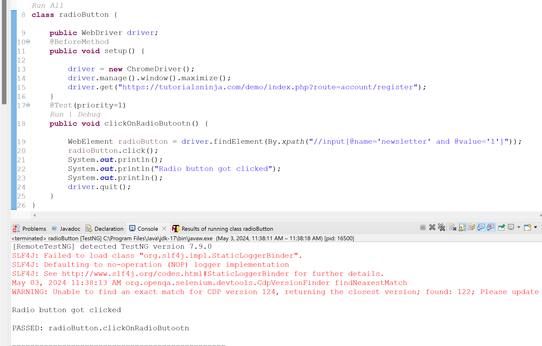

----------------------------------------------------------------------------------------------------------------------------
75. Why do you get NoSuchElementException?

Ans: when the desired element cannot be located using the specified locator.

----------------------------------------------------------------------------------------------------------------------------
76. How can we fetch the page source in Selenium?
Ans:

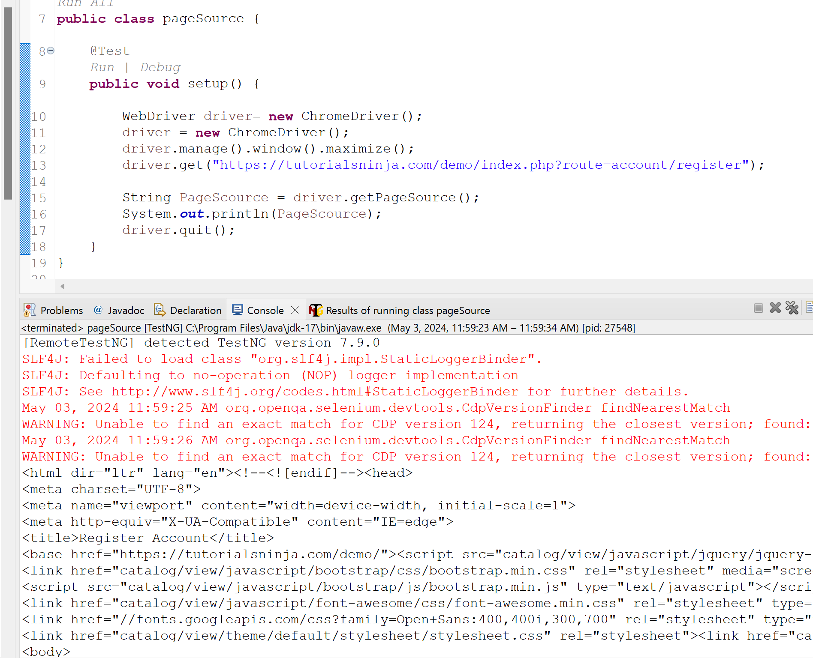

----------------------------------------------------------------------------------------------------------------------------

77. How can we fetch the title of the page in Selenium?

Ans:
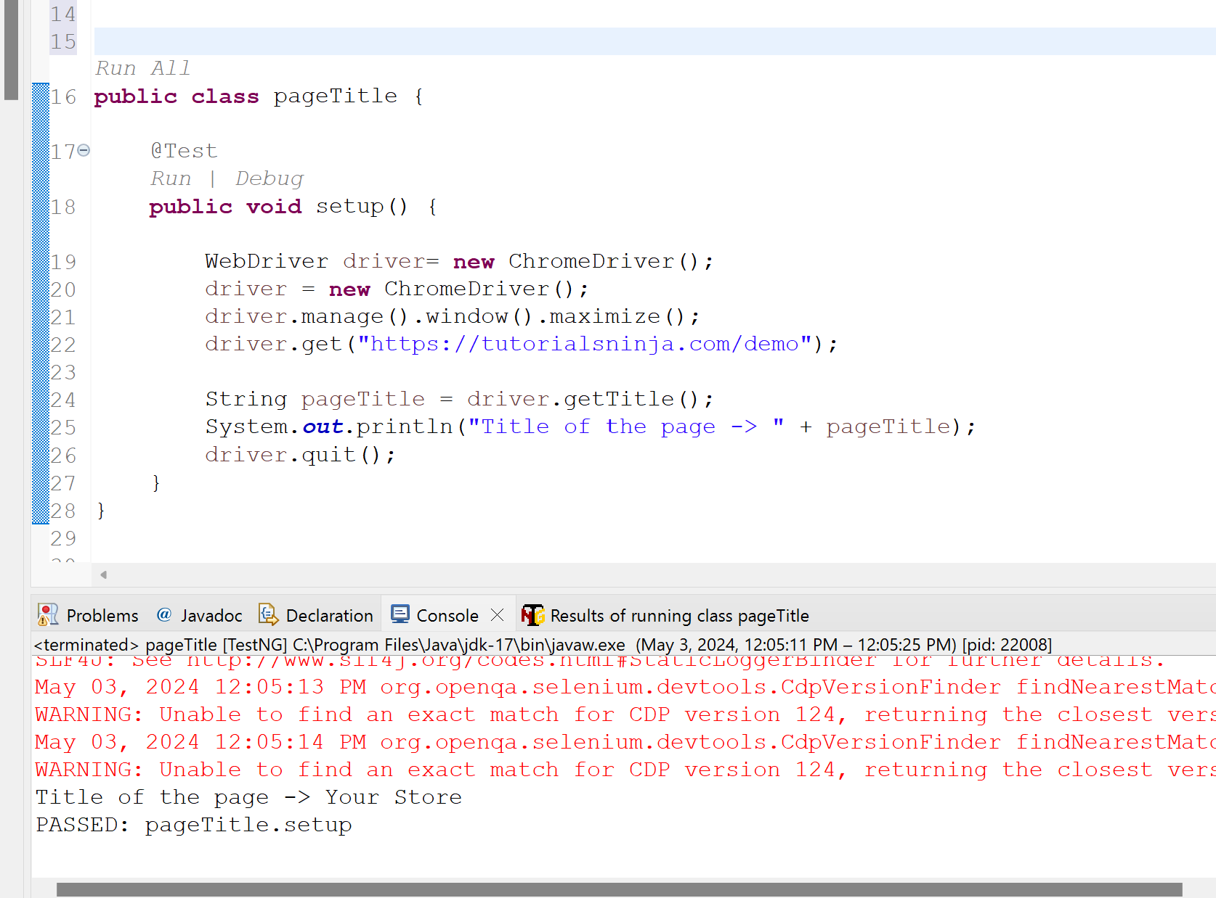

----------------------------------------------------------------------------------------------------------------------------

78. What is the difference between static and instance variable in Java?

Ans:

Static Variables:
- Class-Level Variables: Static variables are declared using the static keyword within a class. They belong to the class itself, not to any specific instance of the class.
- Shared Memory: There's only one copy of a static variable in memory, regardless of how many objects of the class are created. All objects of the class share the same value for the static variable.
- Access: You can access a static variable using the class name itself, without needing an object instance.
Object-Level Variables: Instance variables, also known as member variables, are declared within a class but outside any method (constructor, static method, or instance method). They are associated with individual objects of the class.
- Unique Memory: Each object of the class has its own copy of the instance variables. Changes made to an instance variable in one object won't affect the same variable in other objects.
- Access: You can access an instance variable using the object reference (e.g., this.variableName) within instance methods of the class.

----------------------------------------------------------------------------------------------------------------------------

79. What is the difference between static and non-static methods in Java?

Ans:

Static Methods:
- Class-Level Methods: Static methods belong to the class itself, not to any specific object of that class. You can call a static method without creating an instance of the class.
- Memory Allocation: Static methods are loaded when the class is loaded into memory. There's only one copy of a static method in memory, regardless of how many objects of the class are created.
- Use Cases: Static methods are typically used for utility functions that don't require access to instance-specific data. Examples include mathematical functions, conversion methods, or helper functions that operate on generic data types.
Non-Static Methods (Instance Methods):
- Object-Level Methods: Non-static methods, also known as instance methods, are associated with objects of a class. You need to create an instance (object) of the class to call a non-static method.
- Memory Allocation: Non-static methods are allocated memory whenever a new object of the class is created. Each object has its own copy of the non-static methods.
- Use Cases: Non-static methods typically operate on the data of a specific object. They access and manipulate the object's instance variables. Examples include methods that modify an object's state, perform calculations based on the object's properties, or interact with other objects.

----------------------------------------------------------------------------------------------------------------------------

80. What happens on specifying final modifier with variables & methods in Java?

Ans:The final keyword in Java serves multiple purposes depending on its context.

Once Assigned, Unchangeable: When you declare a variable as final, its value cannot be modified after the initial assignment. This enforces immutability for that variable.

Initialization: A final variable must be initialized either during declaration or within a constructor using the this keyword. You cannot leave it uninitialized.

Use Cases: Use final for constants (unchanging values) like mathematical constants, conversion factors, or configuration settings. It improves code readability and prevents accidental modifications.

Final Methods:
- Prevents Overriding: Declaring a method as final in a parent class prevents subclasses from overriding that method. The method's implementation remains final in the parent class.
Use Cases: Use final for methods that should have a single, definitive implementation and shouldn't be changed in subclasses. This can be useful for core functionalities or utility methods.

the final keyword promotes immutability (unchanging state) and prevents modifications where desired in your Java code.

----------------------------------------------------------------------------------------------------------------------------

81. What is the difference between abstract classes and interfaces in Java?

Ans: Abstract classes and interfaces are both mechanisms in Java that promote abstraction, but they serve different purposes:

- Partial Abstraction: Abstract classes define a blueprint for subclasses. They can have a mix of abstract (unimplemented) methods and concrete (implemented) methods.
- Inheritance: Subclasses inherit from abstract classes and must implement all abstract methods declared in the parent class. This enforces a contract between the abstract class and its subclasses.
- Can Have State: Abstract classes can contain member variables (both static and non-static) to store data relevant to the concept they represent.
- Use Cases: Abstract classes are useful for defining a base class with common functionalities and abstract methods that subclasses must implement to provide specific behavior. They are often used to model a concept with variations but share core properties.
Interfaces:
- Complete Abstraction: Interfaces only contain abstract methods. They define a contract that any class implementing the interface must adhere to.
- Multiple Inheritance: A class can implement multiple interfaces, inheriting the methods from each interface. This allows for greater flexibility in defining behavior.
- No State: Interfaces cannot have member variables. They focus solely on defining method signatures (names and parameter lists) without implementation details.
- Use Cases: Interfaces are ideal for defining contracts or behaviors that can be implemented by various unrelated classes. They promote loose coupling and encourage code reusability.

----------------------------------------------------------------------------------------------------------------------------
[DOCUMENT TITLE] | PANDA, SARTHAK

82. What is the keyword used for inheriting the interfaces in Java?

Ans: “Implements” keyword

----------------------------------------------------------------------------------------------------------------------------
83. Can Captcha be automated using Selenium?
Ans: No, automating Captcha using Selenium directly in Java is generally not recommended and can be unreliable. Captchas are designed to prevent bots from accessing websites, and automating them would defeat their purpose.

----------------------------------------------------------------------------------------------------------------------------

84. How to clear the text inside the text box fields using Selenium WebDriver?

Ans:

Using clear() methods
driver.findElement(By.id(“textbox”)).clear();

----------------------------------------------------------------------------------------------------------------------------

85. What is the default timeout of Selenium WebDriver?

Ans: The default timeout in Selenium WebDriver depends on the type of wait command used.
For implicit waits, the default timeout is 0 seconds.
For pageloads, the default timeout is 300 seconds.

----------------------------------------------------------------------------------------------------------------------------
86. How can we submit a form in Selenium?
Ans:
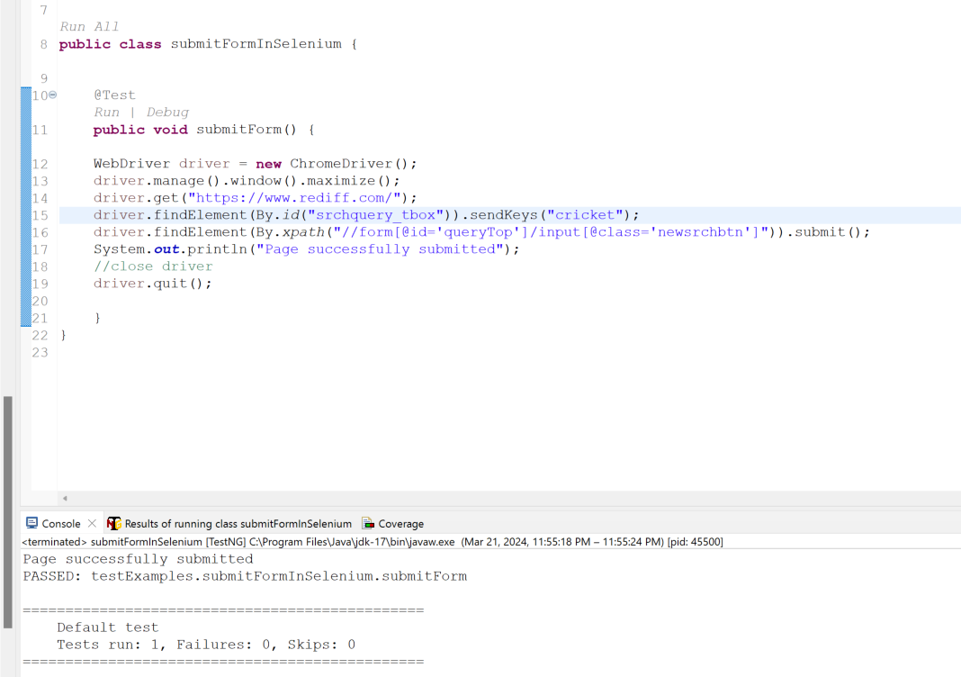

----------------------------------------------------------------------------------------------------------------------------

87. What is the purpose of getOptions() method?

Ans: Basically getoptions() returns All options belonging to your select tag. It finds value in sequence.

For Example:-

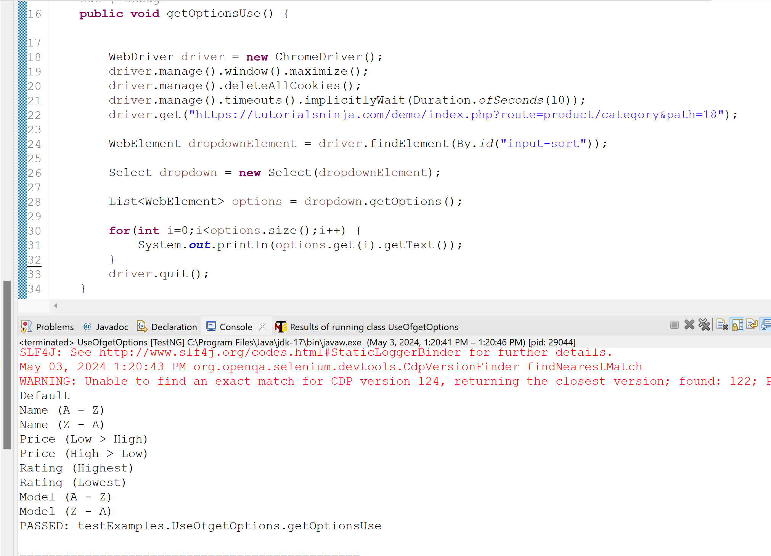

----------------------------------------------------------------------------------------------------------------------------

88. Write an XPath to find all the hyper-links on a web page?
Ans:

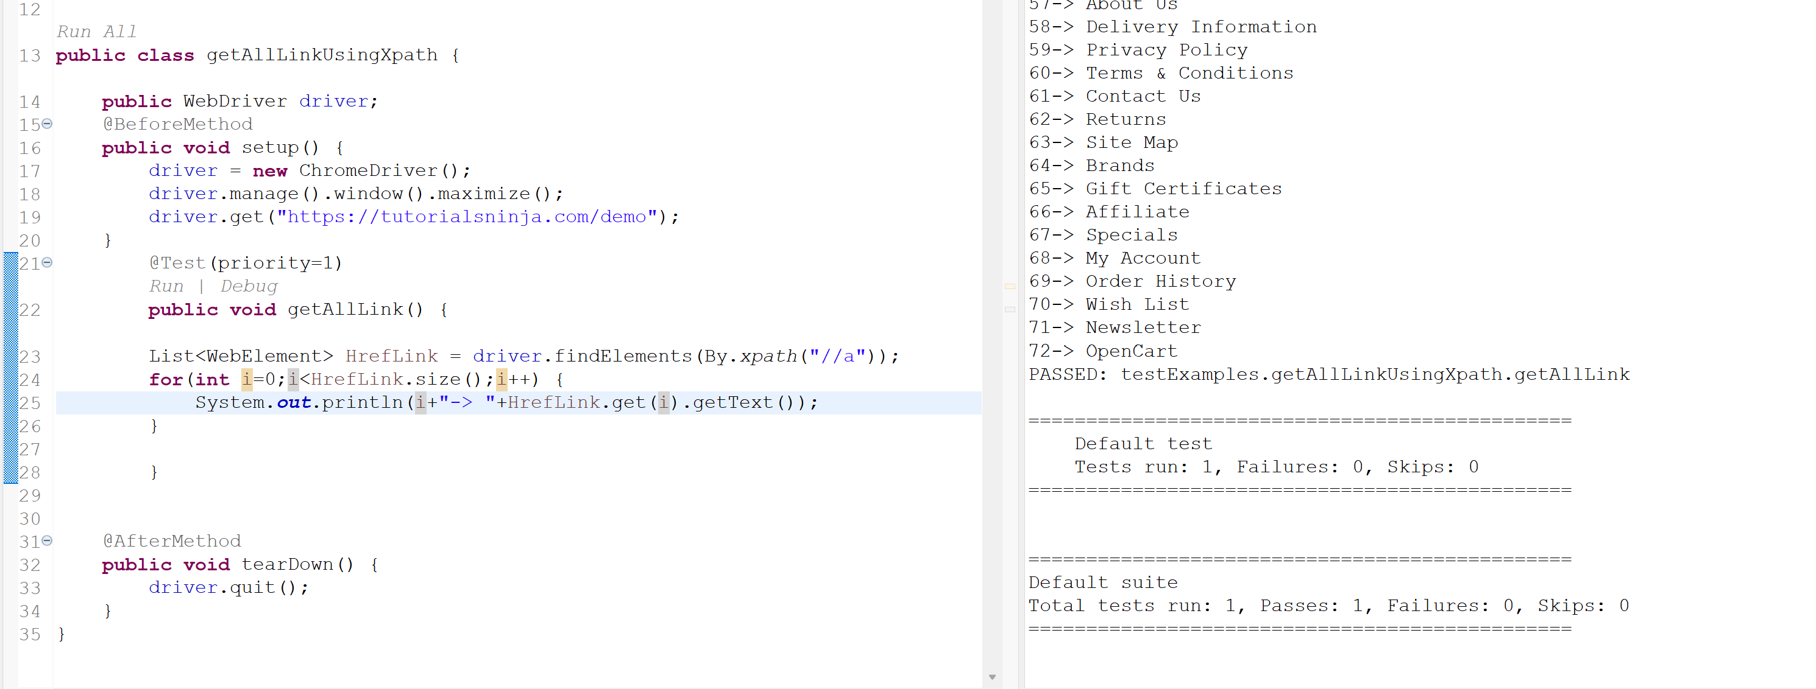

----------------------------------------------------------------------------------------------------------------------------

89. What is Select Class in Selenium WebDriver and how to use it?
Ans:

The Select class in Selenium WebDriver is used to select and deselect options in a dropdown list. It implements the HTML SELECT tag and provides helper methods for selecting and deselecting options. The Select class can be used to select values in drop-down lists.

For example:

Select select = new Select(driver.findElement(By.id("elementId")));
select.selectByVisibleText("Jun");
----------------------------------------------------------------------------------------------------------------------------

90. How to handle alerts in Selenium WebDriver?

Ans: git link added below. CTRL+CLICK to open the link
https://github.com/kazitami/BOOTCAMP2/commit/c71ef177d0778ef4fe75239d27e0fe250004e992#diff-3da884d56125f9518c62bea1082f4a2e826026025c89111e266641f47a211e20

----------------------------------------------------------------------------------------------------------------------------
91. What is click() command in Selenium WebDriver?
Ans:The click() command in Selenium WebDriver simulates a mouse click on web elements like buttons, links, checkboxes, and radio buttons.

----------------------------------------------------------------------------------------------------------------------------

[DOCUMENT TITLE] | PANDA, SARTHAK

92. What is sendKeys() command in Selenium WebDriver?
Ans:
Selenium Sendkeys is a method used in Selenium WebDriver to simulate the typing of a keyboard key in a web application. With the help of this method, you can send data as input to a text field or other form elements.

----------------------------------------------------------------------------------------------------------------------------
93. How to delete cookies in Selenium?
Ans:
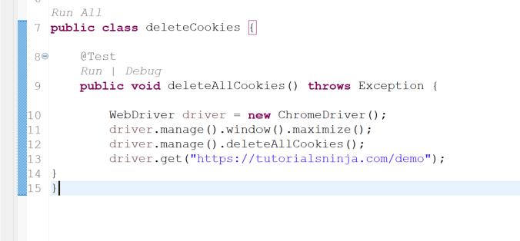

----------------------------------------------------------------------------------------------------------------------------
94. How to get the href of a link?
Ans:

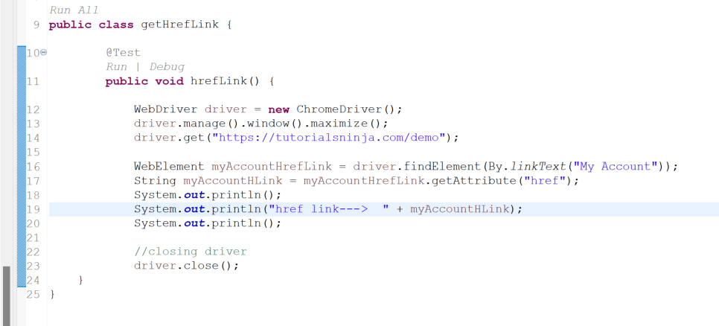
----------------------------------------------------------------------------------------------------------------------------

95. How do you click on a menu item in a drop down menu?
Ans: git link added below. CTRL+CLICK to open the link

https://github.com/kazitami/BOOTCAMP2/commit/0284dd00cbd9ce9aa50a3b8f9f03cab7010196ee

----------------------------------------------------------------------------------------------------------------------------

96. How to get typed text from a textbox?
Ans: By using getAttribute(); method we can get value from textbox.
For example:

WebElement textBoxElement = driver.findElement(By.id(“textboxId”));

textBoxElement.sendKeys(“Hello World!”);

String enteretText = textBoxElement.getAttribute(“Value”);
System.out.print(enteretText);

----------------------------------------------------------------------------------------------------------------------------
97. How to type text in a new line inside a text area?
Ans: git link added below. CTRL+CLICK to open the link

https://github.com/kazitami/BOOTCAMP2/commit/e00888b96bbcea5a3fbb0bb29c7ceb6a82326069#diff-a81f868af43a3cf66c5fc0bedc7526db266ed53bf8c3b583d9c45acb4e04a2ed

----------------------------------------------------------------------------------------------------------------------------

98. How to resize browser window using Selenium WebDriver?
Ans: git link added below. CTRL+CLICK to open the link

https://github.com/kazitami/BOOTCAMP2/commit/9ea8b57bf49f5593e1954795769050036cc49014#diff-194a42e299779767a35cdea2920b4d474823977c9dd1669f819e36241b14150e

----------------------------------------------------------------------------------------------------------------------------
99. How to scroll web page up and down using Selenium WebDriver?
Ans: git link added below. CTRL+CLICK to open the link

https://github.com/kazitami/BOOTCAMP2/blob/master/src/test/java/scrollUpAndDown.java

----------------------------------------------------------------------------------------------------------------------------
100. How to perform right click (Context Click) action in Selenium WebDriver?

Ans: git link added below. CTRL+CLICK to open the link

https://github.com/kazitami/BOOTCAMP2/commit/d4e72af1bdbb9d5480c295c8a8f9599ee93e2c7c#diff-8dfce310045e4f0e23cc39d8d1a89c9de7cd11cf4cd9a82bb66a58f82019ac3a

----------------------------------------------------------------------------------------------------------------------------
101. How to perform double click action in Selenium WebDriver?

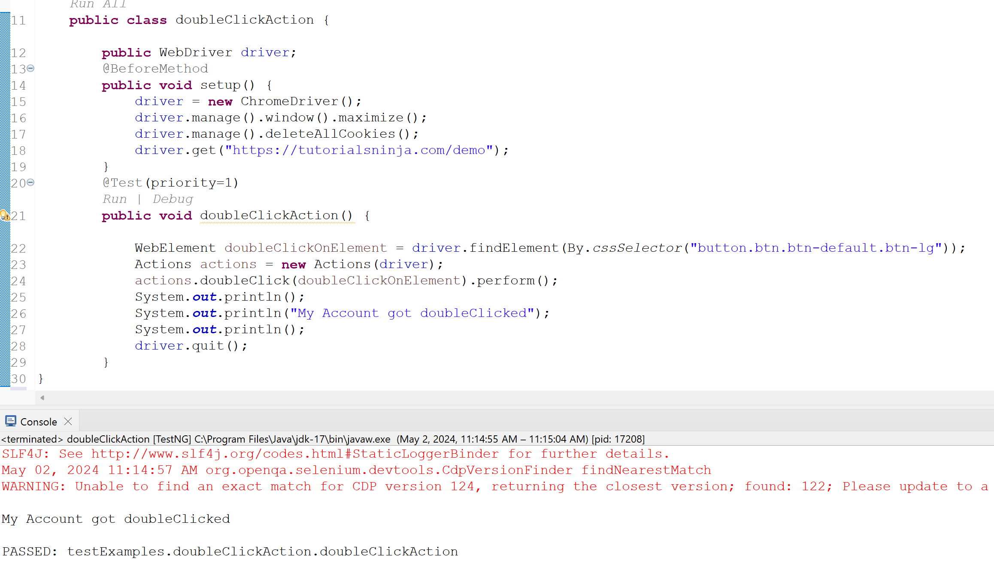

----------------------------------------------------------------------------------------------------------------------------

[DOCUMENT TITLE] | PANDA, SARTHAK

102. How to perform drag and drop action in Selenium WebDriver?

Ans: git link added below. CTRL+CLICK to open the link

https://github.com/kazitami/BOOTCAMP2/commit/709c6506c5de97a8e8a07ad4d1635f33a7c3a64a#diff-72d4cb58c39fc2f8cddd82b33b62d8ce66ffa4628dd23b377bdf40a4c5721805

----------------------------------------------------------------------------------------------------------------------------

THANK YOU!

[DOCUMENT TITLE] | PANDA, SARTHAK

